Project Report

Esrs is a gaming accessories E-commerce cross platform mobile application for Buyer and seller .There are two mobile applications one is for buyer and the other one is for seller. Both the applications are developed is flutter cross platform.

Technical requirements

Editor- Android studio/Intellj,Xcode(For iOS debugging)

SDK-Android, Flutter

Technologies

Frontend-

Flutter,Android,Ios

Backend

Firebase store, Firebase Database.

Functionalities:

Esrs Seller’s Application-

* Seller can login using Email id,Password or Gmail
* He can upload products category wise and update product quantity
* He can view order list and accept or reject the order

If seller accept/reject the product order it will immediately reflect in buyers order list with message.

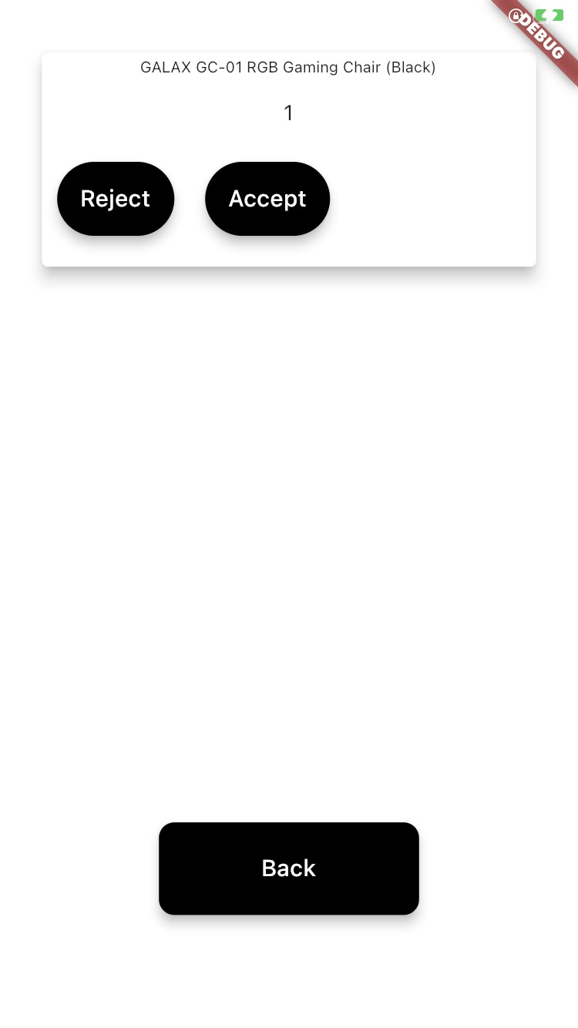

Esrs Buyer,s Application-

* Buyer can login with email or Gmail
* After successful Login buyer will be able to see Homepage-

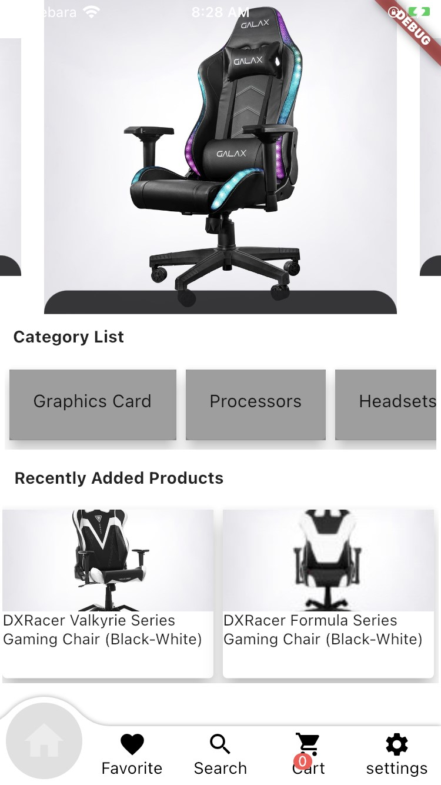

User Can Add products in favourite list.

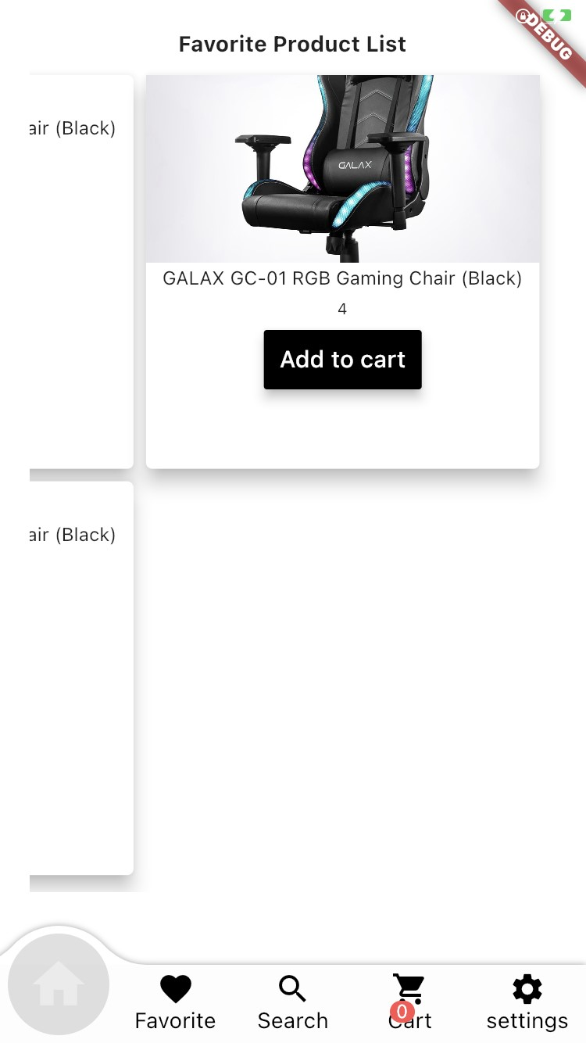

User can add favorite list product to cart and vice versa

User can search product by name. Or he can filter the products by price, by category.

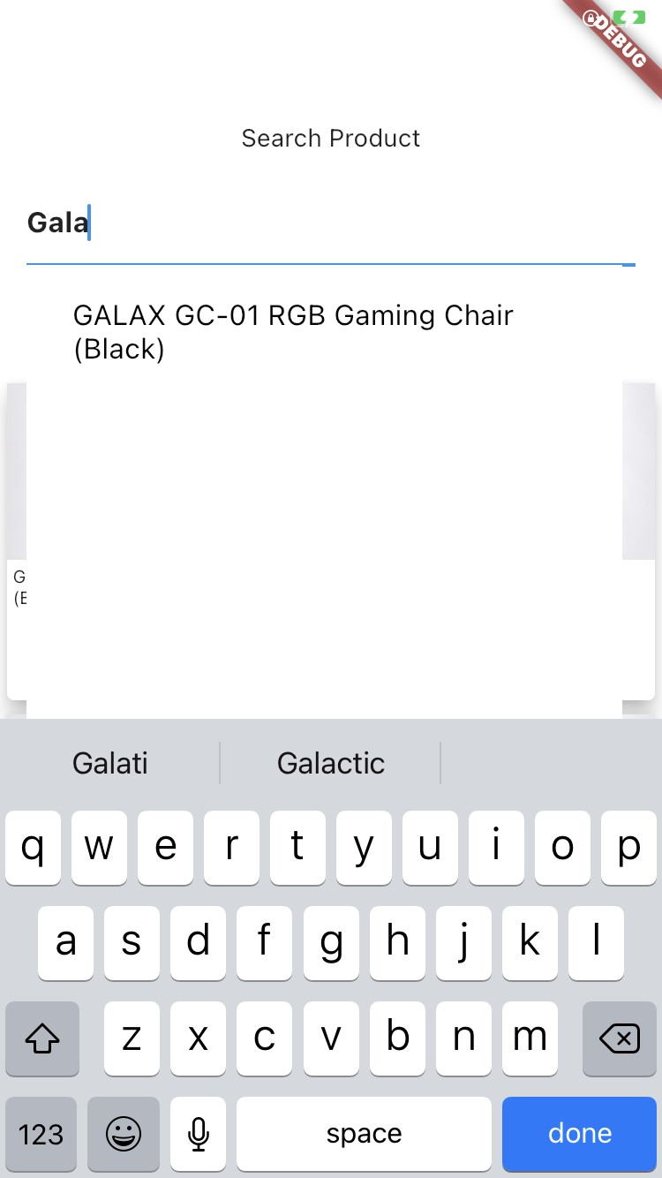

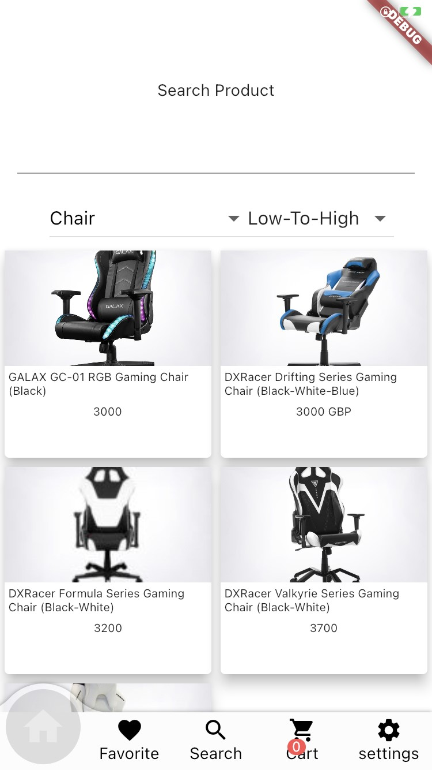

User can view Product details

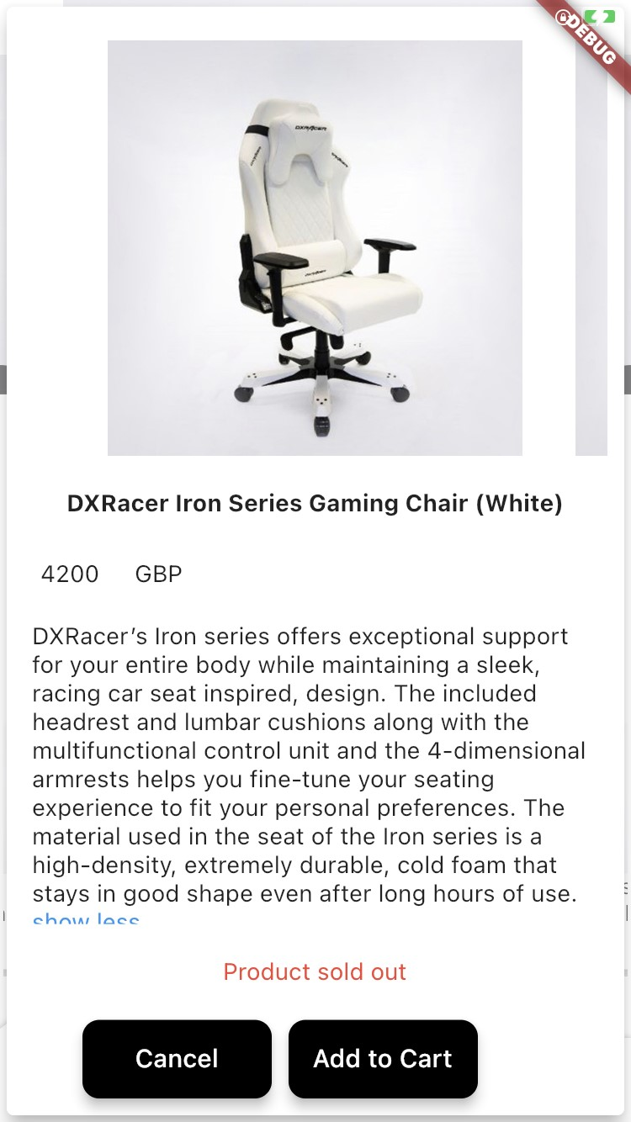

User can update profile

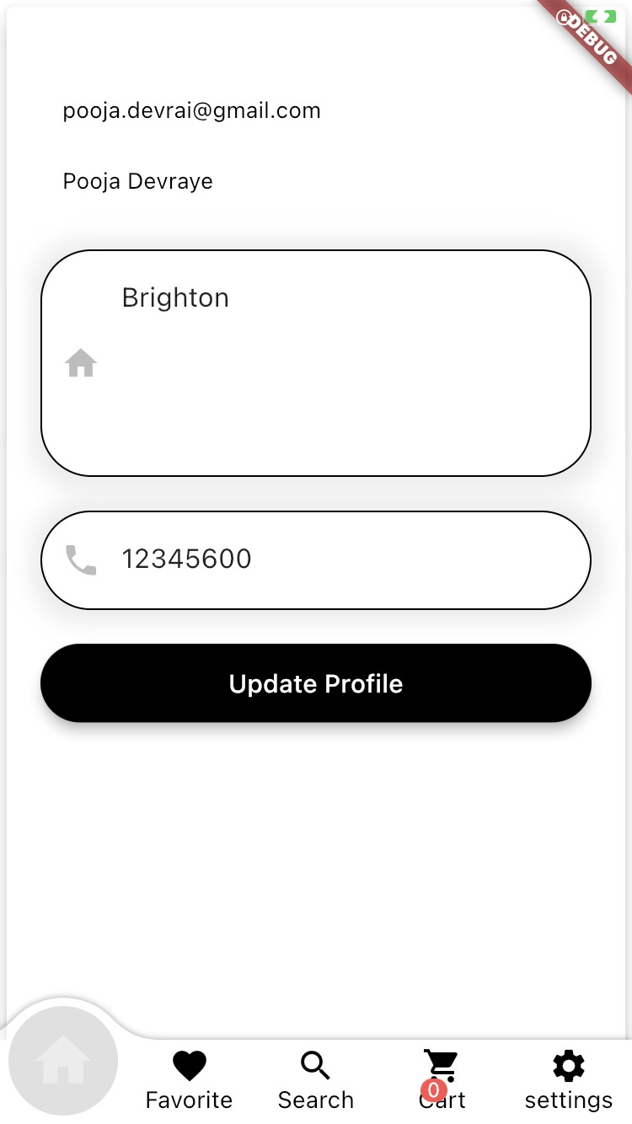

User can view settings on settings page he will have options like logout,profile,order history

Order history



When user order any product-that order will be shown to that particular sellers order list in seller app. In seller App if seller accepts the order then user order status will be updated immediately weather its accepted or rejected. (this synchronization achieved by using

Firebase streams which updates real time data)



Why I choose Flutter and Firebase

Flutter is a cross platform SDK and for designing user interface it is very flexible. flutter have good support for Androis and ios. Development is fast and lots of libraries are available.

Backend FireBase

FireBase is Realtime database which handle large amount of data with speed. I have uploaded more than 150 images on Firebase storage and i released it upload images and data very fast.

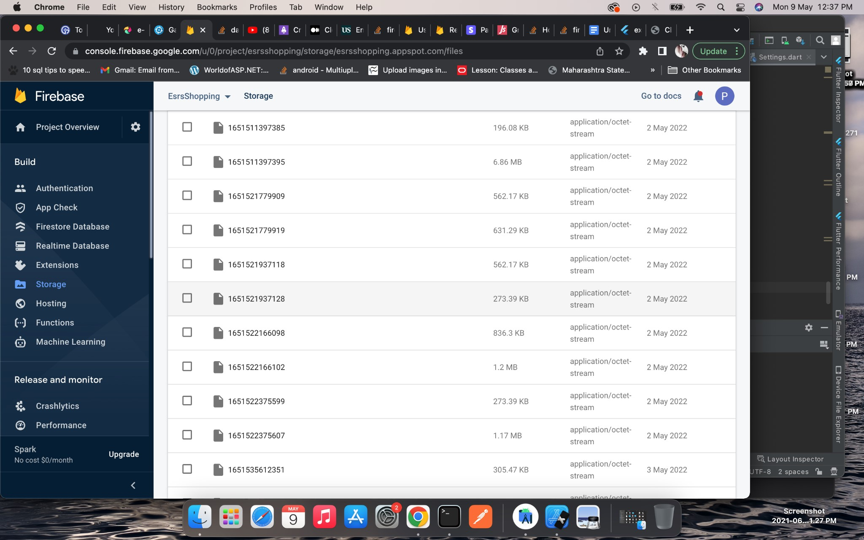

Firebase can handle large amount of data.

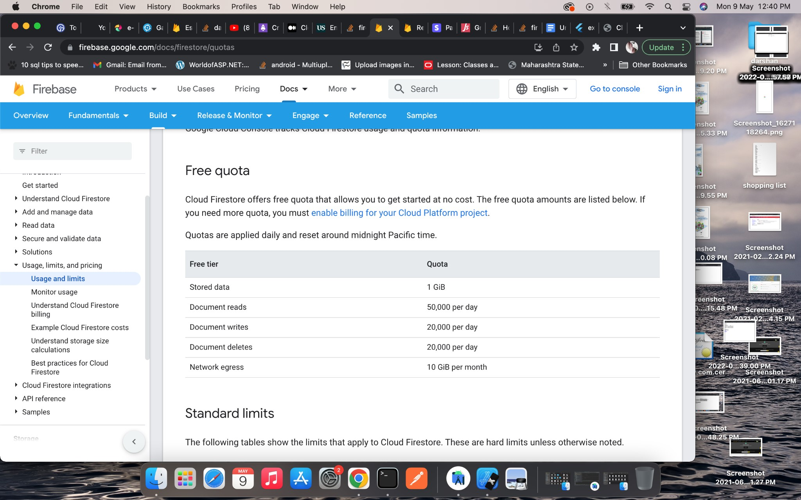

There is one drawback of Firebase database -For complex database structure firebase is not recommended. As it stored collections with documents. It is hard to manage if your database structure is complex or you need joins.

For example i face challenges to store and fetch Order data

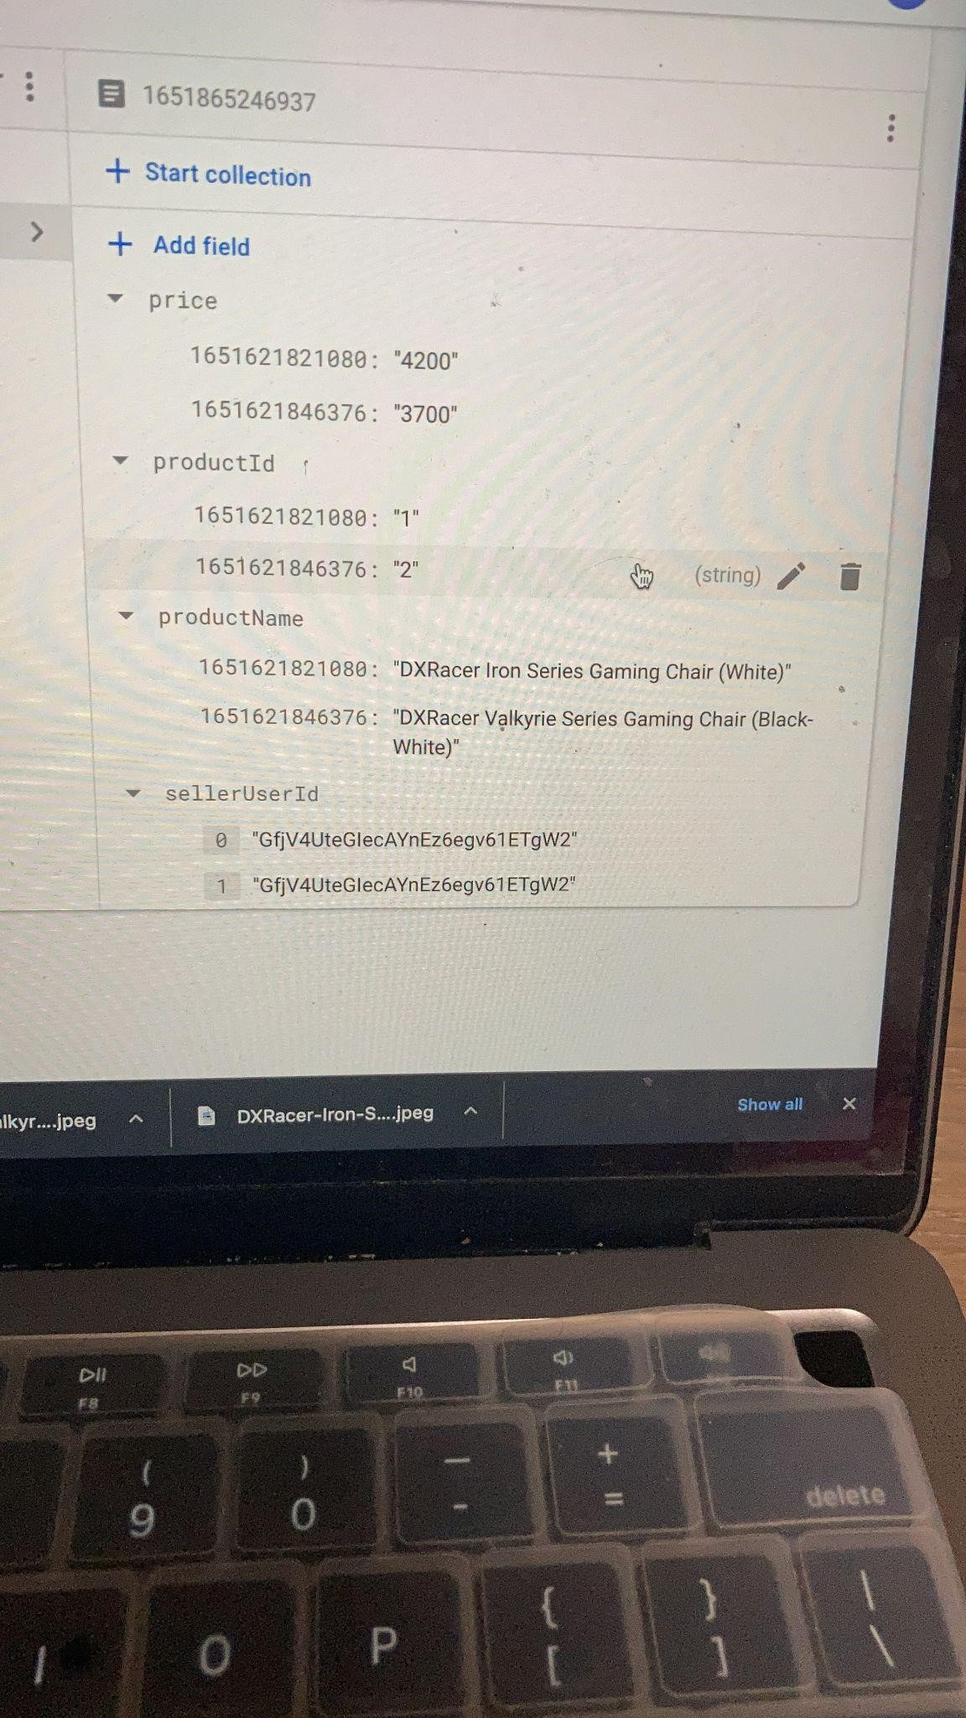

Stripe Paymnet Gateway

Integrated Stripe Payment Gatway with test data.

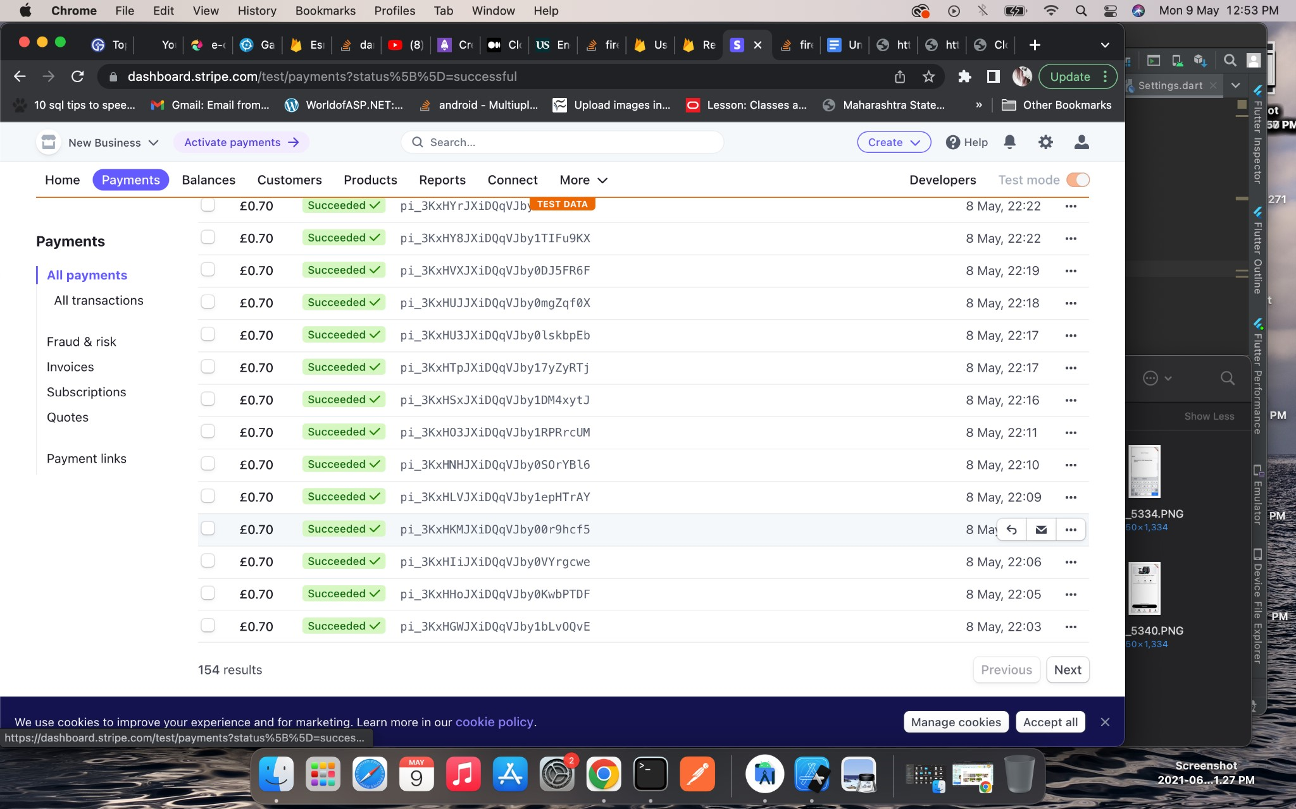

Buyer and seller application is connected with same real time firebase database so any changes quickly reflected in both the applications